**How To Run Chapter 8 Example Code**

**BasicPsa**

Notice: Due to the very nature of Print System Apps, a working utility that could be run for all printer is not realistic – these apps are print hardware specific. Instead, you should open the solution (\Code\BasicPsa\BasicPsa\BasicPsa.sln) and run it under the Debugger. This PSA will work for most newer HP printers – for example the M528, M577, M608, M806, and more. To test this PSA with another printer, you will need to make a registry association in the HKEY_LOCAL_MACHINE\SYSTEM\CurrentControlSet\Control\Print \PSA\Association hive. Chapter 8 goes over how this is done and how to get the values necessary. Below is a graphic that associates an HP printer to the GUID of the PSA app.

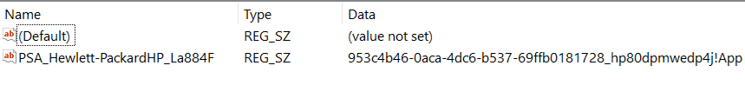

Please refer to the chapter 8 section “Making the Association” for more details.